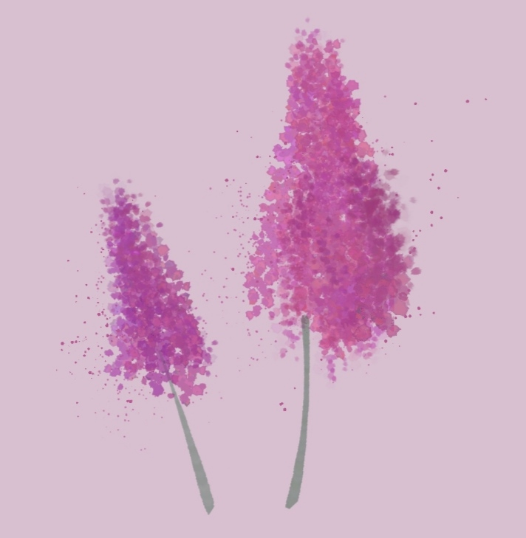

**February 16, 2022**

**Table of content**

1. Information about our team 2

2. Recap 2

2.1 Main goal 2

2.2 Tasks 2

2.3 Realisation (apps and language that we used) 2

3. Structure 3

3.1 Block scheme 4

4. Summary 5

# **Information about our team**

|  |  |  |
| --- | --- | --- |
| Name | Class | Roles |
| Vasilen Mihaylov | 10 G | **Scrum Trainer** |
| Stoqn Ivanov | 10 V | **Back-end Developer** |
| Vesela Dekova | 10 A | **Front-end Developer** |
| Mariq Ilcheva | 10 V | **Front-end Developer** |
| Polina Petrova | 10 B | **QA Engineer** |

# **Recap**

## **Main goal**

Our main goal was to make a program, helping you add, edit, remove, connect or visualize events.

## 2.2 Tasks

1. We assigned roles.
2. Front-end
3. Back-end
4. Connect front-end to back-end
5. We made presentation, documentation and README file.

## **2.3 Realisation (apps and language that we used)**

1. Apps, that we used:

* **Teams** and **GitHub** and **Discord** for communication and team synchronization.
* **Visual Studio** for writing the code.
* **Adobe Illustrator** for making all logos, designs and illustrations
* **PowerPoint** and **Word** for the making of the presentation and documentation.
* **Excel** for the making of the QA documentation

1. Programming language(s) that we used:

* **C++**

# **Structure**

**3.1 Block scheme**

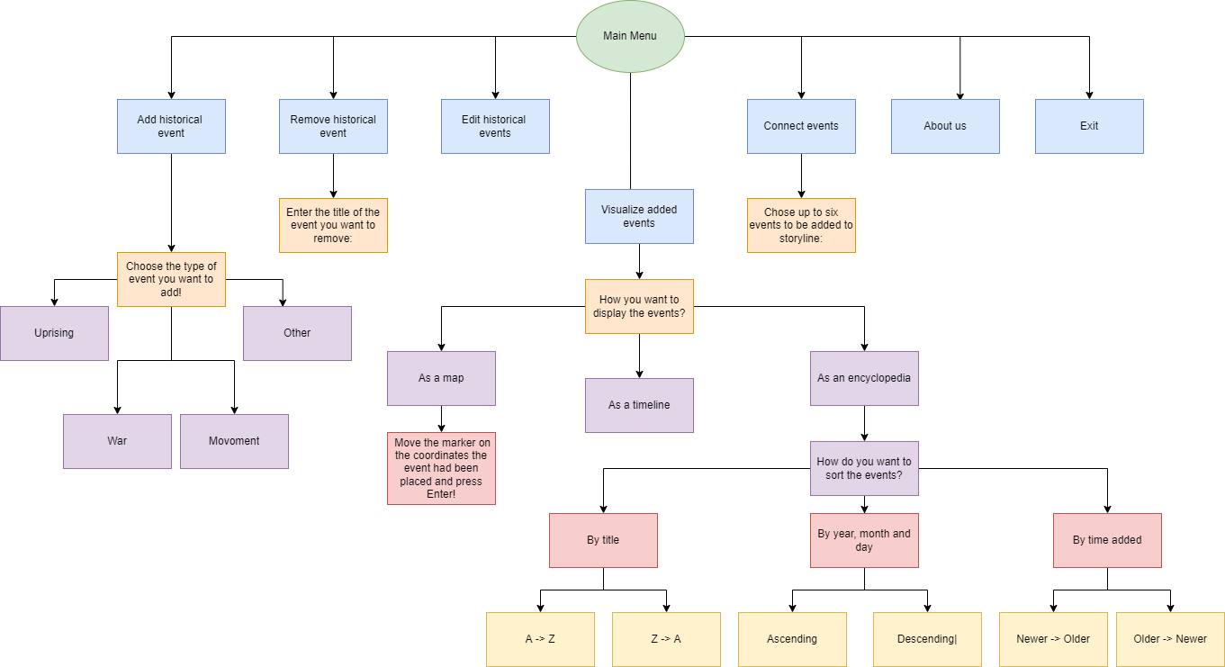

# **Summary**

We are a team of five people, developing a project to help you add , edit, remove, connect or visualize different new events. In our repository you can find our README file, link to our Documentation and Presentation and our project